Sales Data Analysis and Visualization

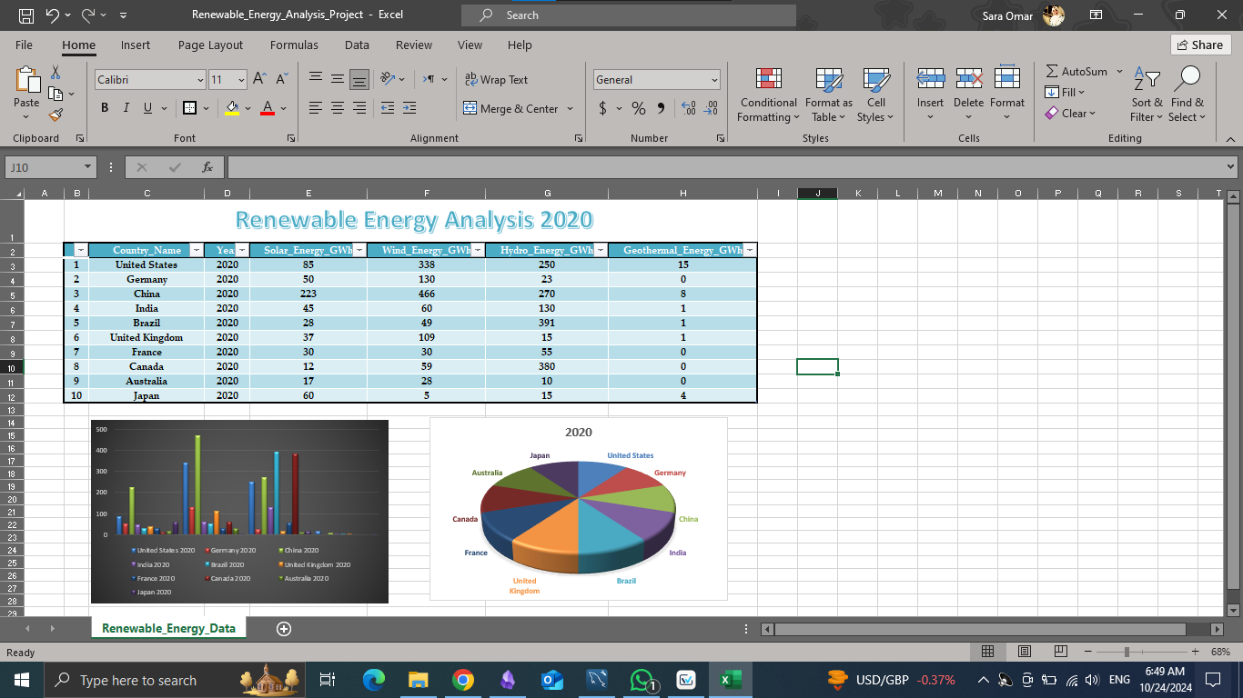

1. Project Overview
In this project, we will analyze sales data from a fictional retail store. We will explore key metrics like total sales, average sales, sales by product category, and sales trends over time. We will use Python for data analysis and visualization.

2. Tools Used
- - Python
- - Pandas
- - Matplotlib
- - Seaborn

3. Dataset
You can use a sample dataset like "Superstore Sales" from Kaggle or create a fictional CSV file with the following columns:
- - Order ID
- - Date
- - Customer ID
- - Product
- - Category
- - Quantity
- - Price
- - Total Sales

4. Code

```python
Import necessary libraries
import pandas as pd
import matplotlib.pyplot as plt
import seaborn as sns
Load the dataset
data = pd.read_csv('sales_data.csv')
Display the first few rows of the dataset
print(data.head())
Check for missing values
print(data.isnull().sum())
Data Cleaning - Remove missing values (if any)
data = data.dropna()
Convert the 'Date' column to a datetime format
data['Date'] = pd.to_datetime(data['Date'])
Add a new column 'Month' to analyze monthly sales
data['Month'] = data['Date'].dt.month
Basic statistics
print(data.describe())
Total sales by product category
category_sales = data.groupby('Category')['Total Sales'].sum().reset_index()
Plot total sales by category
plt.figure(figsize=(8, 6))
sns.barplot(x='Category', y='Total Sales', data=category_sales)
plt.title('Total Sales by Category')
plt.xlabel('Product Category')
plt.ylabel('Total Sales')
plt.xticks(rotation=45)
plt.show()
Total sales over time
monthly_sales = data.groupby('Month')['Total Sales'].sum().reset_index()
Plot total sales by month
plt.figure(figsize=(10, 6))
sns.lineplot(x='Month', y='Total Sales', data=monthly_sales, marker='o')
plt.title('Monthly Sales Trend')
plt.xlabel('Month')
plt.ylabel('Total Sales')
plt.grid(True)
plt.show()
Sales distribution by product
plt.figure(figsize=(12, 8))
sns.boxplot(x='Category', y='Total Sales', data=data)
plt.title('Sales Distribution by Category')
plt.xlabel('Product Category')
plt.ylabel('Total Sales')
plt.xticks(rotation=45)
plt.show()
Top 5 products by total sales
top_products = data.groupby('Product')['Total Sales'].sum().sort_values(ascending=False).head(5)
print("Top 5 Products by Total Sales:")
print(top_products)
```

5. Explanation
- Data Loading and Cleaning: We load the dataset and check for missing values. If there are any, we remove them.
- Feature Engineering: We convert the `Date` column to a datetime format and extract the month to analyze monthly sales trends.
- Data Analysis: We use grouping to analyze sales by category and month. We then plot these using bar charts and line plots.
- Visualization: Using Seaborn and Matplotlib, we create visualizations to present our findings, making it easy to understand the data.

6. Conclusion
- - The project shows how to analyze and visualize sales data, extract key insights, and present them effectively.
- - You can expand this project by adding more complex visualizations, using more detailed datasets, or building a dashboard using tools like Power BI or Tableau.

7. Dataset Example (CSV)
Create a CSV file named `sales_data.csv` with the following structure:
```csv
Order ID,Date,Customer ID,Product,Category,Quantity,Price,Total Sales
1001,2024-01-05,C001,Notebook,Office Supplies,2,15.99,31.98
1002,2024-01-07,C002,Chair,Furniture,1,75.50,75.50
1003,2024-01-10,C003,Printer,Electronics,1,199.99,199.99
...

